Web Designing Assignment

Module (HTML) -1

**1. Are the HTML tags and elements the same thing?**

No, both are different.

**HTML Tags**

HTML tags are used to hold the HTML element.

HTML tag starts with < and ends with >

**HTML Element**

HTML element holds the content.

Whatever written within a HTML tag are HTML elements.

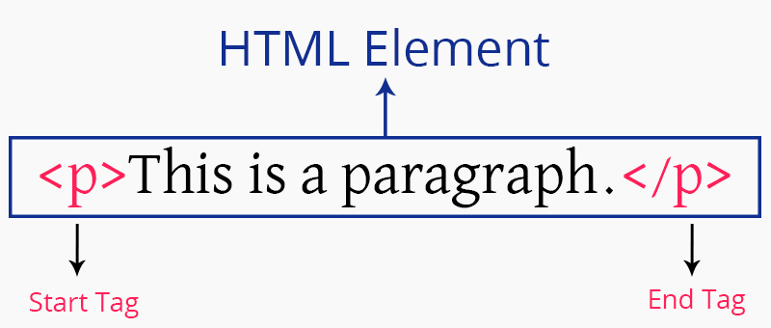

**2. What are tags and attributes in HTML?**

Tags and attributes are the basis of HTML.

Tags-

Tags are used to enclose the HTML elements

Most tags must be opened<> and closed</> to function.

Attributes-

Attributes are additional information which are present in an opening tag.

<img src="mycar.jpg" alt="A photo of my car.">

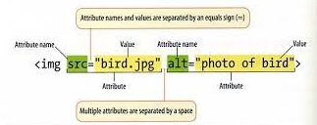

**3. What are void elements in HTML?**

There is a special group of elements that only have start tags and does not contain any content within it, these elements are called void elements

 Void elements doesn’t have ending tags and can only have attributes but do not contain any kind of content.

Example

<br>, <hr>, <img>, <input>, <link>, <base>, <meta>, <param>, <area>, <embed>, <col>, <track>, <source> etc.

**4. HTML Entities?**

An HTML entity is a piece of text ("string") that begins with an ampersand ( & ) and ends with a semicolon ( ; )

&entity_name; OR &#entity_number;

Emojis What are number : &#128512,

&#128513,   
&#128514

**5. What are different types of lists in HTML?**

Lists are used to group together related pieces of information so they are clearly associated with each other and easy to read.

Lists are good from a structural point of view as they help create a well-structured, more accessible, easy-to-maintain document.

The three list types

* **unordered list** — used to group a set of related items in no particular order
* **ordered list** — used to group a set of related items in a specific order
* **description list** — used to display name/value pairs such as terms and definitions

### **Unordered lists**

* milk
* bread
* butter
* coffee beans

**<ul>**

**<li>bread</li>**

**<li>coffee beans</li>**

**<li>milk</li>**

**<li>butter</li>**

**</ul>**

### **Ordered lists**

* 1. bread
  2. coffee
  3. milk
  4. butter

Ordered lists can be displayed with several sequencing options. The default in most browsers is decimal numbers, but there are others available:

* Letters
  + Lowercase ascii letters (a, b, c…)
  + Uppercase ascii letters (A, B, C…).
  + Lowercase classical Greek: (έ, ή, ί…)
* Numbers
  + Decimal numbers (1, 2, 3…)
  + Decimal numbers with leading zeros (01, 02, 03…)
  + Lowercase Roman numerals (i, ii, iii…)
  + Uppercase Roman numerals (I, II, III…)
  + Traditional Georgian numbering (an, ban, gan…)
  + Traditional Armenian numbering (mek, yerku, yerek…)

#### Beginning ordered lists with numbers other than 1

A common requirement in ordered list usage is to get them to start with a number other than 1 (or i, or I, etc.). This is done using the **start** attribute,

### **Description lists**

**coffee**

**a beverage made from roasted, ground coffee beans**

**a cup of coffee**

**a social gathering at which coffee is consumed**

**a medium to dark brown colour**

## Nesting lists

An individual list item can contain another entire list, called a nested list.

**1. Chapter One**

**a. Section One**

**b. Section Two**

**c. Section Three**

**2. Chapter Two**

**3. Chapter Three**

**<ol>**

**<li>Chapter One**

**<ol>**

**<li>Section One</li>**

**<li>Section Two </li>**

**<li>Section Three </li>**

**</ol>**

**</li>**

**<li>Chapter Two</li>**

**<li>Chapter Three </li>**

**</ol>**

**6. What is the ‘class’ attribute in HTML?**

 The class attribute **specifies one or more classnames for an element**. The class attribute is mostly used to point to a class in a style sheet. However, it can also be used by a JavaScript (via the HTML DOM) to make changes to HTML elements with a specified class.

Example

<html>  
<head>  
<style>  
h1.intro

{  
    color: blue;  
}  
  
p.important

{  
    color: green;  
}  
</style>  
</head>  
<body>  
  
<h1 class="intro">Header 1</h1>  
<p>A paragraph.</p>  
<p class="important">Note that this is an important paragraph. :)</p>  
  
</body>  
</html>

**7. What is the difference between the ‘id’ attribute and the ‘class’ attribute of HTML elements?**

The only difference between them is that **“id” is unique in a page and can only apply to at most one element, while “class” selector can apply to multiple elements**.

Example

Id.html

!DOCTYPE html>

<html>

<head>

<title>

Id demo

</title>

<style>

   #idDemo{

      color:green;

      font-size:25px;

   }

</style>

</head>

<body style="text-align:center">

<h1>Get element by Id</h1>

<p id="idDemo">Demo for Id selector</p>

</body>

</html>

Class.html

<!DOCTYPE html>

<html>

<head>

<title>

Class demo

</title>

<style>

   .classDemo{

    color:orange;

      font-size:25px;

   }

</style>

</head>

<body style="text-align:center">

<h1>Get element by class</h1>

<p class="classDemo">Demo for class selector</p>

</body>

</html>

**8. What are the various formatting tags in HTML?**

HTML facilitates the ability for formatting text just like we do in MS Word or any text editing software

* <b> - Bold text
* <strong> - Important text
* <i> - Italic text
* <em> - Emphasized text
* <mark> - Marked text
* <small> - Smaller text
* <del> - Deleted text
* <ins> - Inserted text
* <sub> - Subscript text
* <sup> - Superscript text

**9. How is Cell Padding different from Cell Spacing?**

Cell padding

Cellpadding basically defines the space present between a table cell's border and the content present in it. It deals with a single cell.

Cell spacing

Cellspacing basically defines the space present between individual adjacent cells. t gets subjected to multiple cells (more than one) at a time.

<!DOCTYPE html>

<html lang="en">

<head>

<title>Document</title>

<style>

span{

text-decoration-style: solid;

width: 25px;

font-size: x-large;

color: blueviolet;

}

</style>

</head>

<body>

<table border="1" cellpadding="4" cellspacing="5">

<thead>

<td><span>Name</span></td>

<td><span>Age</span></td>

</thead>

<tbody>

<tr>

<td>Rani</td>

<td>30</td>

</tr>

<tr>

<td>Rajan</td>

<td>35</td>

</tr>

<tr>

<td>Akshaya</td>

<td>17</td>

</tr>

<tr>

<td>Ashick</td>

<td>13</td>

</tr>

</tbody>

</table>

</body>

</html>

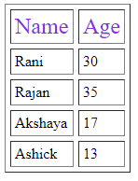

**10. How can we club two or more rows or columns into a single row or column in an HTML table?**

To merge cells in HTML, use the colspan and rowspan attribute.

The rowspan attribute is for the number of rows a cell should span,

 the colspan attribute is for a number of columns a cell should span.

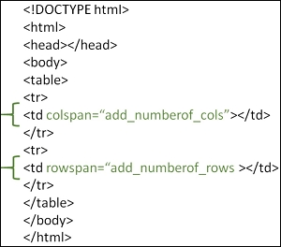

**11. What is the difference between a block-level element and an inline element?**

**inline elements do not force a new line to begin in the document flow.**

**Block elements, on the other hand, typically cause a line break to occur** (although, as usual, this can be changed using CSS).

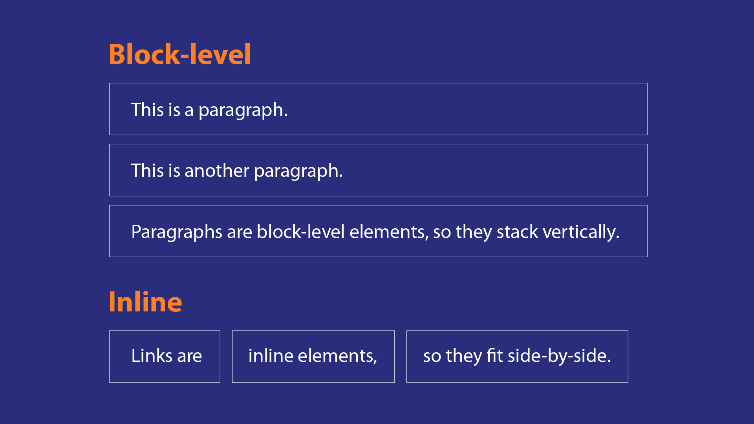

**12. How to create a Hyperlink in HTML?**

To make a hyperlink in an HTML page, **use the <a> and </a> tags**, which are the tags used to define the links. The <a> tag indicates where the hyperlink starts and the </a> tag indicates where it ends.

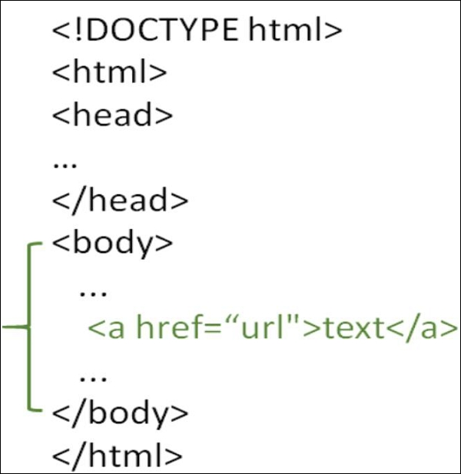

**13. What is the use of an iframe tag?**

The <iframe> tag **specifies an inline frame**. An inline frame is used to embed another document within the current HTML document.

<iframe src="https://www.google.com" title="Practicals"></iframe>

**14. What is the use of a span tag? Explain with example?**

The <span> tag is an inline container used to mark up a part of a text, or a part of a document

<p>Hello <span style="color:blue"> Good </span> morning.</p>

**15. How to insert a picture into a background image of a web page?**

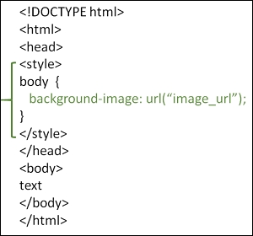

**16. How are active links different from normal links?**

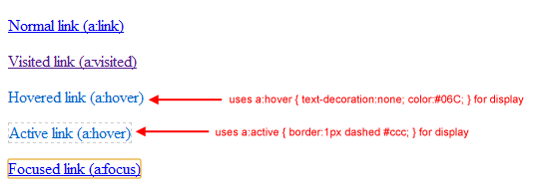

**17. What are the different tags to separate sections of text?**

<br> tag – Usually <br> tag is used to separate the line of text. It breaks the current line and conveys the flow to the next line.

<p> tag – This contains the text in the form of a new paragraph.

<blockquote> tag – It is used to define a large quoted section.

**18. What is SVG?**

SVG stands for Scalable Vector Graphics.

SVG defines vector-based graphics in XML format.

<html>  
<body>  
  
<h1>My first SVG</h1>  
  
<svg width="100" height="100">  
  <circle cx="50" cy="50" r="40" stroke="green" stroke-width="4" fill="yellow" />  
</svg>  
  
</body>  
</html>

**19. What is difference between HTML and XHTML?**

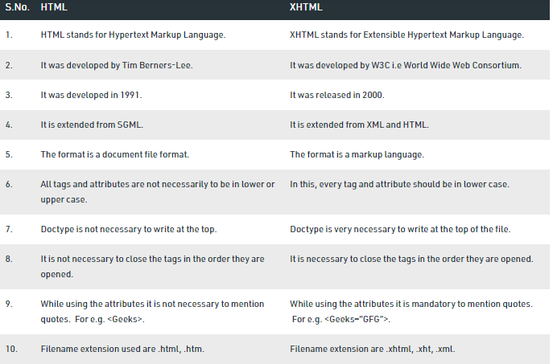

**20. What are logical and physical tags in HTML??**

Logical tags describe the behavior

Physical tags are used to decide the appearance of the text and do not provide any information about the text.

**Physical Tags**

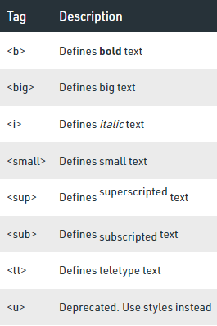

**Logical Tags**